Project Development Phase
Model Performance Test

Date | 26 Jan 2026
Team ID | LTVIP2026TMIDS64924
Project Name | Smart sorting
Maximum Marks | 4 Marks

Model Performance Testing:
S.No. | Parameter | Values | Screenshot
1. | Model Summary | Input Shape : (224, 224, 3)  Number of Classes : 29  Total Parameters : 27,575,135  (~105.19 MB)  Trainable Parameters : 12,860,445  (~49.06 MB)  Non-trainable Parameters : 14,714,688  (~56.13 MB)  Optimizer Parameters : 2 (~12  Bytes)  Top Dense Layer Size : 512 units  Final Output Layer : Dense(29)  Dropout Layer Used : Yes (before final output)  Base Model : VGG16 (pre-trained on  ImageNet)  Architecture Summary :  - 5 Convolutional Blocks (Conv2D +  MaxPooling2D)  - Flatten layer  - Dense(512) + Dropout  - Dense(29) for classification | 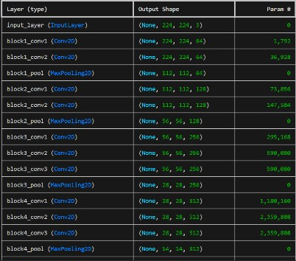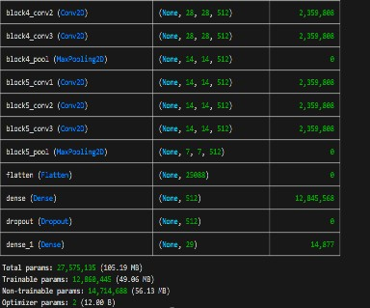
2. | Accuracy | Training Accuracy : 94.00% Validation Accuracy: 93.20% | 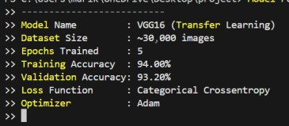
3. | Fine Tunning  Result( if  Done) | Validation Accuracy -91.43% | 